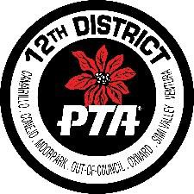
12TH District PTA
Graduating High School Senior Scholarship Application

12th District PTA is awarding four (4) $500 scholarships to high school seniors attending PTA/PTSA schools in Ventura County. The scholarships are being awarded to seniors who have exhibited outstanding service and volunteerism to their school and community. Applications are due to 12th District PTA on or before March 31st, 2017.

A successful applicant must be a high school senior, with a minimum 2.5 GPA and a member of your school’s PTA/PTSA.
Name:
Phone: Address: City: _ Zip Code: Email address: High School:

Attach the following documents to this application:
- A resume or list of your extracurricular and volunteering activities
- A copy of your current PTA/PTSA membership card
- Essays answering the following two questions. No minimum number of words are required per answer, but each answer may not exceed one typed page. Do not include your name on or in your essay answer. Grammar and spelling counts, so please check your work.
  - What have you done during your high school years to give back to your high school and local community?
  - Why do you think volunteering is important for teens?
- Two recommendations from teachers or adults with whom you have worked closely during your volunteering. Please make sure there is contact information for all those providing you with letters of recommendation.
**Applications that do not follow these instructions, or are received late, will be disqualified.
All information must be received by 12th District PTA by March 31st, 2017. Applications can be mailed to 12th District PTA, P.O. Box 6771, Thousand Oaks, CA 91359; faxed to 805.416.2390 or scanned and emailed to 12thscholarships@gmail.com
Award winners will be notified in May of 2017.

